To prepare for class, an assessment needs to be taken. Please click the link below.
DISC personality test (2023) | take this free DISC assessment at 123test.com

You will answer the questions with a thumbs up most like you and thumbs down least like you.
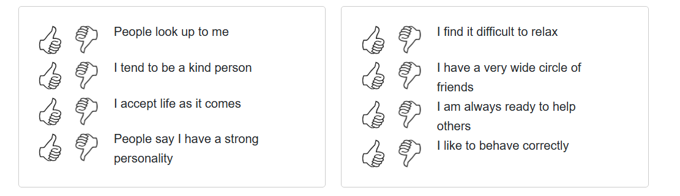

Then fill out the demographics information.
You will then receive your results….
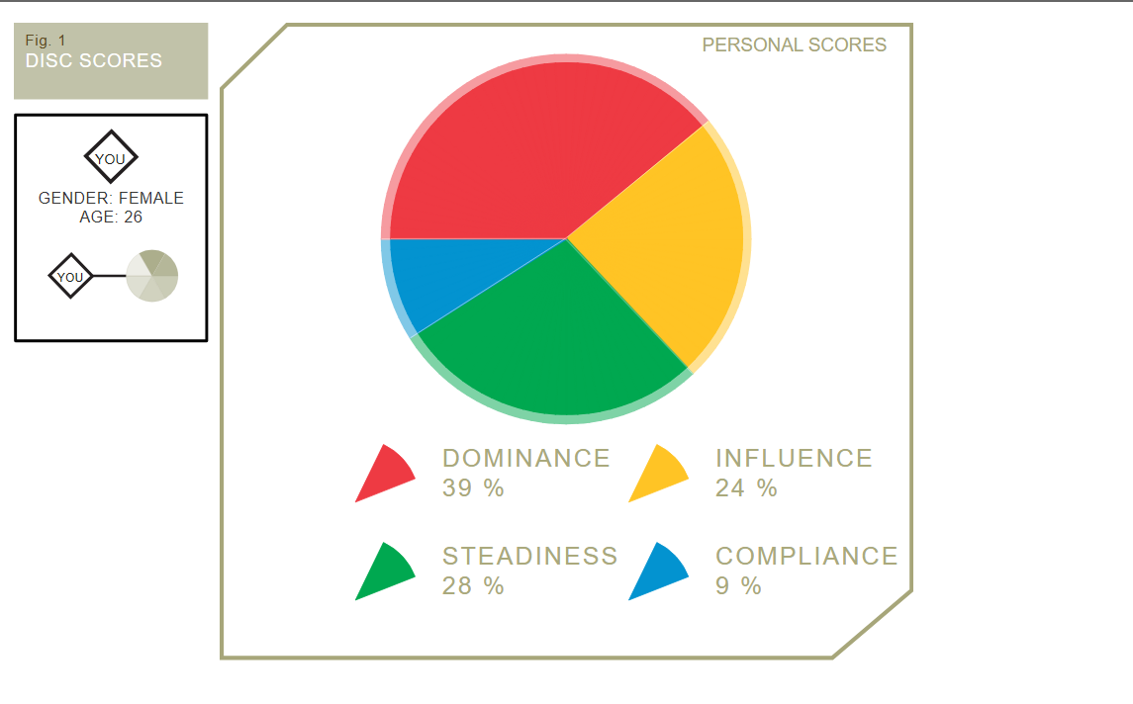
Click on this link (https://forms.gle/Au2viDKPS545bLWm8) and report your percentages in the google doc. See you in class. If you have any question please reach out to nicolelmccartan@gmail.com

